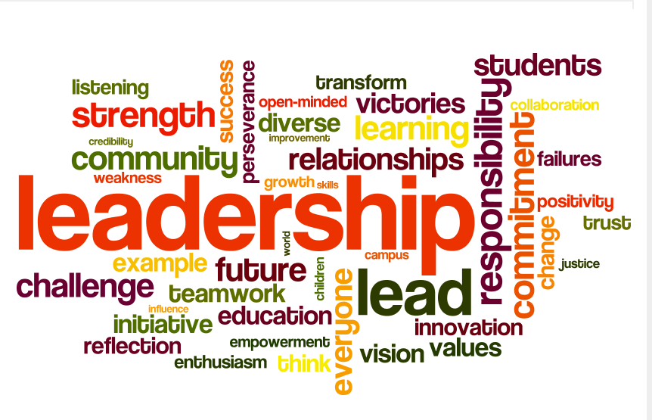
Developing Others as Leaders. There are four key areas where leaders need to be equally balanced. The fourth is learning to effectively develop other leaders. This area is more than just teaching others how to do the basics of Premier. To truly develop others, we must teach them how to develop themselves as leaders which includes teaching them how to develop leaders on their teams. This is where leaders get duplicated. The result of this is a large jewelry business! Use these trouble shooting questions to assess your how you develop others as leaders. The ultimate goal of a leader is to help develop the leaders around you!

‘—‘ Not confident in this area ‘+/-‘ I can do with effort but I’m not confident ‘+’ I so got this!
All items in red are possible “helps” when a line item is answered with a ‘-‘ or ‘+/-“. All handouts mentioned are on www.MitchellGems.com ID:Mitchell pw:Gems

Do You ….. (These are two-fold. You must be developed in these areas so you can teach others! The second part to each is do you know how to teach your jewelers to do these)

_____ Lead by Example? Your team is watching and your actions speak louder than your words! They will do what you do! The best thing you can do for your team to be continually growing in the first three areas of your business.

_____ Know who to work with on your team? Who to spend the most time with? (80/20 rule, leadership qualities handout)

_____ Know great questions to start business conversations with your jewelers? Handout on questions to ask.

_____ Know how to help your jewelers see their potential and to help them see big? Paint a picture, have high expectations

_____ Know how to separate ministering to someone and truly helping her change her future by building a business?
Long conversations are usually enabling and ministry / short conversations are usually coaching and teaching. Both may be needed at times, but we must understand the business conversations needed to develop your people. We can’t be all rahrah

_____ Know how to use the activity report to help someone see areas for growth and concern? (A few ex: Look at sponsoring ratio, staying at minimums, jewelers not getting past quick start, high number of first levels but few second levels)

_____ Give opportunity for growth at trainings? (Start with small tasks and sharing of ideas and move to segments of training)

_____ Understand the difference in building and maintaining and how to see it in your jeweler’s business? Handout Building vs Maintaining under the Leadership tab
_____ Recognize your jewelers and teach them how to do the same? (at trainings, newsletter, fb, notes, texts, calls, goodies)

_____ Work with your first levels and teach them how to work with their first levels? Don’t do everything for your 10-10-10. It’s all about developing strong jewelers and leaders!

_____ Feel confident in teaching your leaders how to start their own trainings or do smaller gatherings every other month?
Be willing to let them get out of the boat when the time is appropriate. Encourage them and build confidence in them!

_____ Feel confident in teaching your jewelers to share the plan and do an opportunity presentation? You can listen to the pre-recorded OP calls and The Draper’s video to help!

_____ Spend time building others up through your words and actions? (25 ways to win with people book)

_____ Know how to be kind but not nice while developing a new leader? (Teach your team to fish book)

_____ Connect jewelers to others that can help them…maybe even more than you?

_____ Encourage your team to attend trainings and rallies and even help financial if the need arises?

_____ Have a system to take someone from jeweler to Designer? Handouts under the Leadership Tab on the Steps to Designer

Allison Mitchell and Tandy Flynn (5/1/2014)

